Mrs. Morgan’s  Student  News |  | 

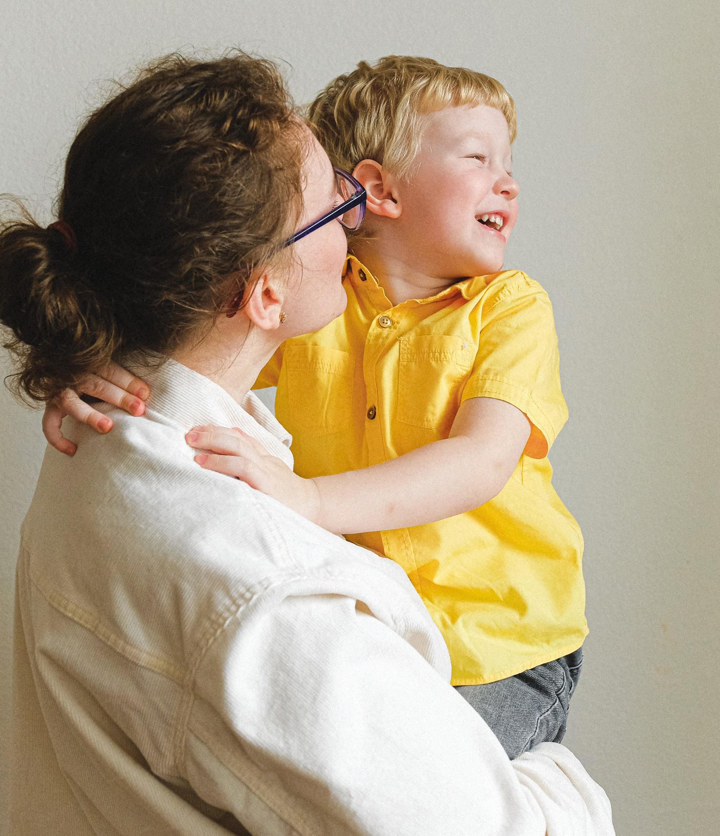 | News for the week of: August 17, 2026  HOMEWORK:  Reading: 20 minutes per night  Spelling Words: recall, vividly, accentuated, partial, splendor, resourceful, disposition, commendable, devastation, exaggerated
WI
 | Content Standards for the Week:  READING: Thunder Rose (Tall Tale)  (SKILLS): Text Features (Captions)  MATH: factors/factor pairs
 | Other Communication:  August:  (14) Chocolate Sales began  (28) No School  September  (4) First Friday  (7) No School  (14) Fall Pictures  (17) Chocolate Sales end  (18) No School  ***Nonfiction Text Features due September 14th***  PLEASE HAVE YOUR CHILD BRING A WATER BOTTLE EVERY DAY ALL YEAR!!

